The Coastal Zone Revision Booklet

The coast is shaped by weathering, mass movement, erosion, transportation and deposition.

There are three groups of weathering. These are:

Physical
Chemical
Biological

Physical

What type of weathering is this?
Explain what is happening at each stage.

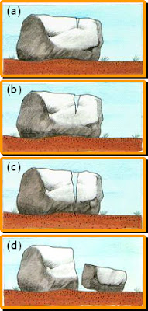

Which type of physical weathering would you find in hot, dry climates?

Explain the processes using the following words: heating cooling expansion contraction cracks_______________________________________________________________________________________________________________________________________________________________________________________________________________________________________________________________________________________________________
Chemical
This happens when the rock’s mineral composition is changed, leading to the disintegration of the rock. The main process of chemical weathering is............................. and this happens in ...................... rocks.

Biological
This is caused by plants and animals.
Explain how both of these cause biological weathering.
_______________________________________________________________________________________________________________________________________________________________________________________________________________________________________________________________________________________________________

Mass movement
There are four types of mass movement which provide an input of material into the coastal system.
L
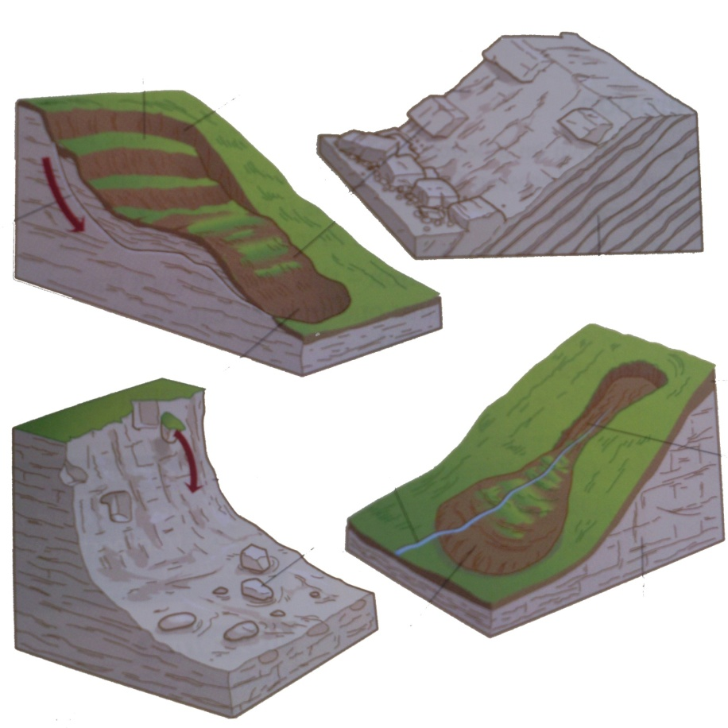
M
Rock______
R S
R S
Coastal Erosion
When a wave crashes down on a beach or smashes against a cliff, it carries out the processes of coastal erosion. There are four to remember:

H A
Ab
S
Att

Coastal Transportation
Four main types of sediment transportation can be identified.
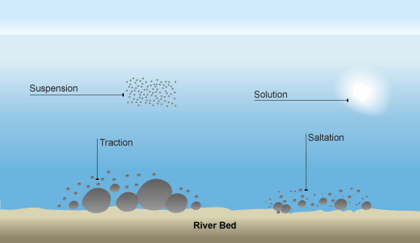

Coastal Deposition
Coastal deposition takes place in areas where the flow of water slows down. Sediment can no longer be carried or rolled along and has to be deposited.
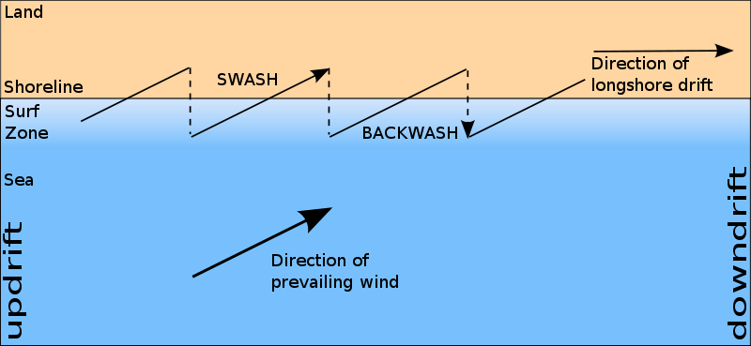

Distinctive landforms result from different processes.

Landforms resulting from erosion –

HEADLANDS AND BAYS

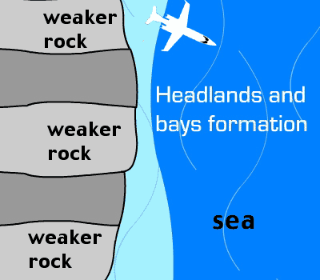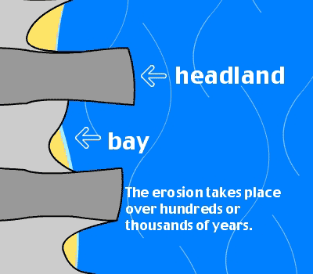

Cliffs rarely erode at an even pace. Sections of resistant rock stick out to form headlands. Weaker sections are more easily eroded to form bays.

CLIFFS AND WAVE CUT PLATFORMS
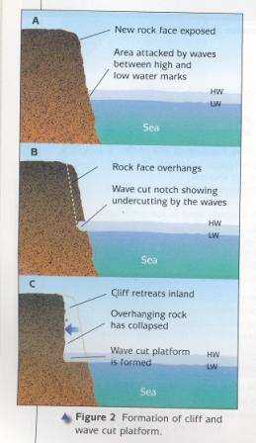

The sea cliff is the most widespread landform of coastal erosion.

CAVES, ARCHES, STACKS, STUMPS
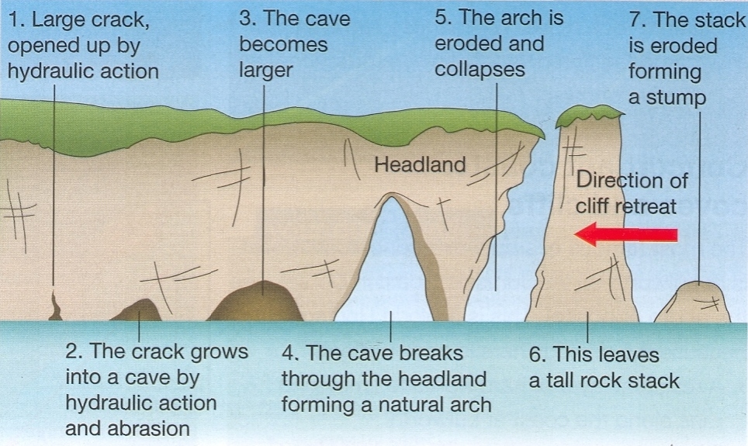

Landforms resulting from deposition –

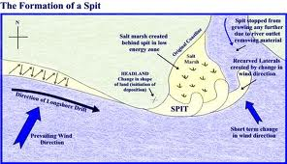

Explain the formation of a spit.

Rising sea level will have important consequences for people living in the
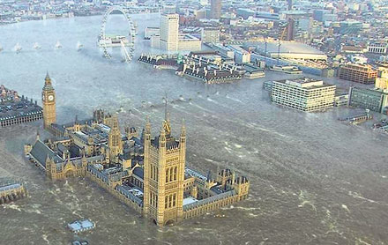
coastal zone.

ESSEX

What is causing rising sea level?
___________________________________________________________________________________________________________________________________________________________________________________________________________________________

Describe 4 possible impacts of sea level rise in East Anglia.
___________________________________________________________________________________________________________________________________________________________________________________________________________________________________________________________________________________________________
___________________________________________________________________________________________________________________________________________________________________________________________________________________________________________________________________________________________________

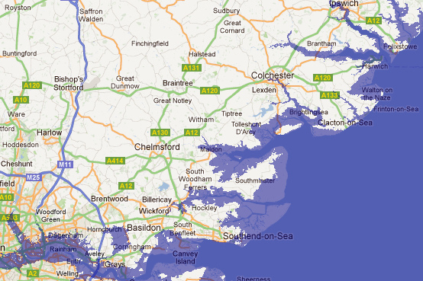
Coastal erosion can lead to cliff collapse. This causes problems for people and the environment.

HOLDERNESS
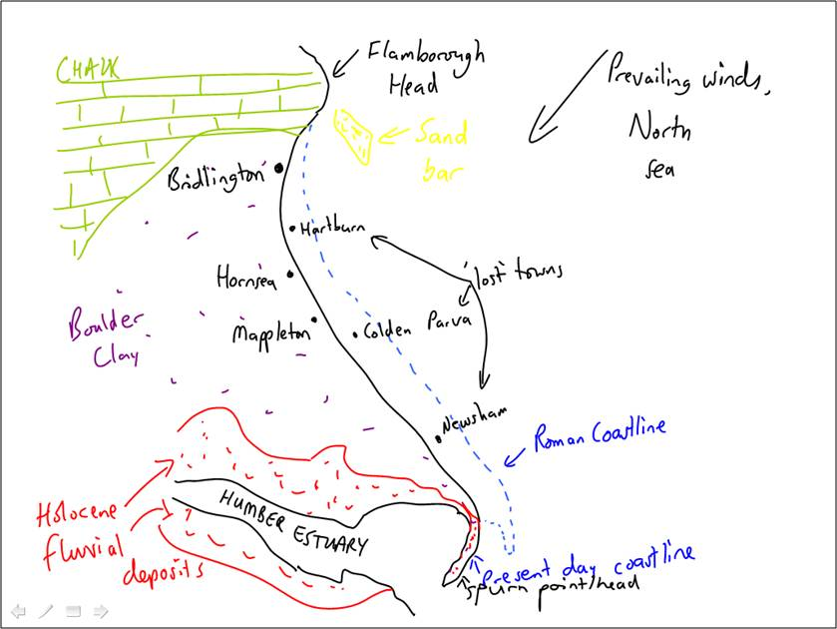

- Where is the Holderness Coast? What is the problem?

___________________________________________________________________________________________________________________________________________________________________________________________________________________________

- Why is Cliff Erosion such a problem here?
_________________________________________________________________________________________________________________________________________________________________________________________________________

- Attempts at Coastal Management along the Holderness Coast include:
_________________________________________________________________________________________________________________________________________________________________________________________________________
_________________________________________________________________________________________________________________________________________________________________________________________________________

- Example of the impacts of Coastal Management: Mappleton
_________________________________________________________________________________________________________________________________________________________________________________________________________
___________________________________________________________________

- Protecting Mappleton
____________________________________________________________________________________________________________________________________________________________________________________________________________________________________________________________________________

- Problems for further down coast
_________________________________________________________________________________________________________________________________________________________________________________________________________
___________________________________________________________________

There is discussion about how the coast should be managed. There is debate about the costs and benefits of ‘hard’ and ‘soft’ engineering.

Engineering | Description | Advantage | Disadvantage
Sea Wall
Groynes
Rock Armour
Beach nourishment
Dune regeneration
Marsh creation

Coastal areas provide a unique environment and habitat. There is a need
for conservation and this leads to conflict with other land uses.

THE ESSEX MARSHES

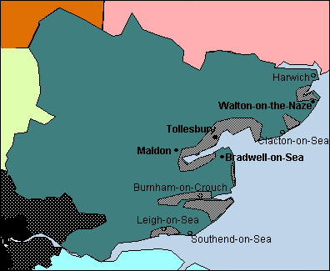

Description
___________________________________________________________________________________________________________________________________________________________________________________________________________________________

Why are they under threat?
___________________________________________________________________________________________________________________________________________________________________________________________________________________________

Strategies for conservation
___________________________________________________________________________________________________________________________________________________________________________________________________________________________________________________________________________________________________
________________________________________________________________________

WEBSITES

http://www.bbc.co.uk/schools/gcsebitesize/geography/coasts/coastal_processes_rev1.shtml

http://www.coolgeography.co.uk/GCSE/AQA/Coastal%20Zone/Coastal%20zone.htm

http://www.geography.learnontheinternet.co.uk/gcse/revision.html

http://www.geography.learnontheinternet.co.uk/gcse/command.html

http://www.geography.learnontheinternet.co.uk/topics/coasts.html

http://www.s-cool.co.uk/gcse/geography/coasts/revise-it/coastal-management-strategies

